**PROJECT REPORT**

**ON**

**WEB DEVELOPMENT PROJECT OF**

**SOLAR ENERGY SOCIETY OF INDIA**

**(STUDENTS’ CHAPTER, NIT SILCHAR)**

**NATIONAL INSTITUTE OF TECHNOLOGY**

**SILCHAR, ASSAM – 788010**



**Submitted in Partial fulfillment of the requirement for internal assessment**

**In**

**Computer Science & Engineering**

Submitted By:

**Abhishek Kumar**

B. Tech, 5th Semester

NIT Silchar

Under the Guidance of

**Mr. Ripon Patgiri**

Assistant Professor, CSE

**TABLE OF CONTENTS**

|  |  |  |
| --- | --- | --- |
| **S. No.** | **PARTICULARS** | **Page No.** |
| **1.** | **Certificate** |  |
| **2.** | **Acknowledgement** |  |
| **3.** | **Abstract** |  |
| **4.** | **Profile of the Organization** |  |
| **5.** | **Introduction** |  |
| **6.** | **System Environment** |  |
| **7.** | **System Design** |  |
| **8.** | **Conclusion** |  |

**National Institute of Technology**

**Silchar, 788010**



**CERTIFICATE**

**This is to certify that the Project Work of a Website entitled**

**Solar Energy Society of India**

**(Students’ Chapter, NIT Silchar)**

**submitted by the following student belonging to 5th semester, B.Tech during the academic session 2014-2015 under the guidance of Mr. Ripon Patgiri, Assistant Professor, Department of Computer Science Engineering, NIT Silchar is a bonafide record of the work done by them.**

**Abhishek Kumar**

**(12-1-5-023)**

**Mr. Ripon Patgiri**

**Project Supervisor**

**Department of CSE**

**NIT Silchar**

**ACKNOWLEDGEMENT**

**We would like to express our sincere gratitude and avail this opportunity to**

**express our indebtedness to our supervisor, Mr. Ripon Patgiri, Assistant Professor,**

**Department of Computer Science Engineering, National Institute of Technology Silchar, for his valuable guidance, constant encouragement and kind help at various stages for the execution of this work. His enthusiasm has always encouraged us to seek for knowledge in all forms of source.**

**We extend our sincere thanks to our respected head of the division Mr. N SINHA sir, for allowing us to use the facilities available. We would like to thank the other faculty members also, at this occasion. Last but not the least, we would like to thank friends for the support and encouragement they have given us during the course of our work.**

**Abhishek Kumar**

**(12-1-5-023)**

**Place: NIT Silchar**

**Date: 25/11/2014**

**ABSTRACT**

**“Solar Energy Society of India, Students Chapter, NIT Silchar” is a very interactive and informatics Website developed for the various activities carried out at the SESI Students’ Chapter, NIT Silchar. For the past few years SESI Students’ Chapter has been responsible for all the work being carried out at NIT Silchar in the field of Solar Energy and Renewable Energy in general. The Students’ Chapter organizes many events and workshops for the students every year.**

**So, it needs to have a portal where all the necessary and vital information about the works being carried out inside the chapter need to be posted, so that the others can view their work. This particular project gives a desired Solution to all such requirements of the Chapter.**

**PROFILE OF THE ORGANIZATION**

**SESI Students' Chapter of NIT-Silchar has been set up to motivate and impart quality research in the field of renewable energy and spreading awareness about renewable in and around NIT Silchar in particular and entire North East in general.**

**The main aim of this chapter is to train the techies and encourage research in the field and hence to generate a valuable workforce for the country. It has been set up to harness the potential of budding technocrats in the field of solar energy. NIT-Silchar is taking giant strides in the field, with a 200KW solar power plant and 75 Solar Street Lights have been set up in the institution with the help of MNRE (Ministry of New and Renewable Energy) for developmental and research purposes. This is one of the largest "SOLAR" power plant being set up under the aegis of an educational institution of the country.**

**INTRODUCTION**

“Solar Energy Society of India, Students Chapter, NIT Silchar” is a very interactive and informatics Website developed for the various activities carried out at the SESI Students’ Chapter, NIT Silchar. The main aim of this chapter is to train the techies and encourage research in the field and hence to generate a valuable workforce for the country. It has been set up to harness the potential of budding technocrats in the field of solar energy. Therefore, there is an inherent need for an online portal where all its work can be showcased so that outer world can also view it.

Identification of the drawbacks of the existing system leads to the designing of computerized system that will be compatible to the existing system with the system which is more user friendly and more GUI oriented. We can improve the efficiency of the system, thus overcome the drawbacks of the existing system.

**User Panel:**

**Home:**

1. This consist of the different pop-up menus showing the details of the various works carried at SESI Students’ chapter, NIT Silchar.
2. It contain a link to the NIT Silchar official web-site and also to the SESI India Website.
3. A user can view all the members, Coordinators, projects, awarda etc. and can also contact us via a contact form.

**Contact Form:**

If any user wants to personally contact the SESI Students’ Chapter, then he simply put his credentials in the contact form displayed on the “contact us” page.

The SESI Chapter will itself reply with the solutions to the qurries asked by the users through the details provided by them in the contact form.

**SYSTEM ENVIRONMENT**

**Hardware Configuration**

1. I3 Processor
2. 4 MB RAM
3. 500GB HDD
4. 1024 * 768 Resolution Color Monitor

**Note: This is not the “System Requirements”.**

**Software Configuration**

For best User Experience use following:

1. Google Chrome
2. Mozilla Firefox
3. Internet Explorer 11.0

**Technology Used**

We have used the following technologies to develop this website:

1. HTML & HTML5
2. CSS, Javascript & jquerry
3. PHP

**SYSTEM DESIGN**

**Important Codes and Snapshots:**

1. **Home Page**

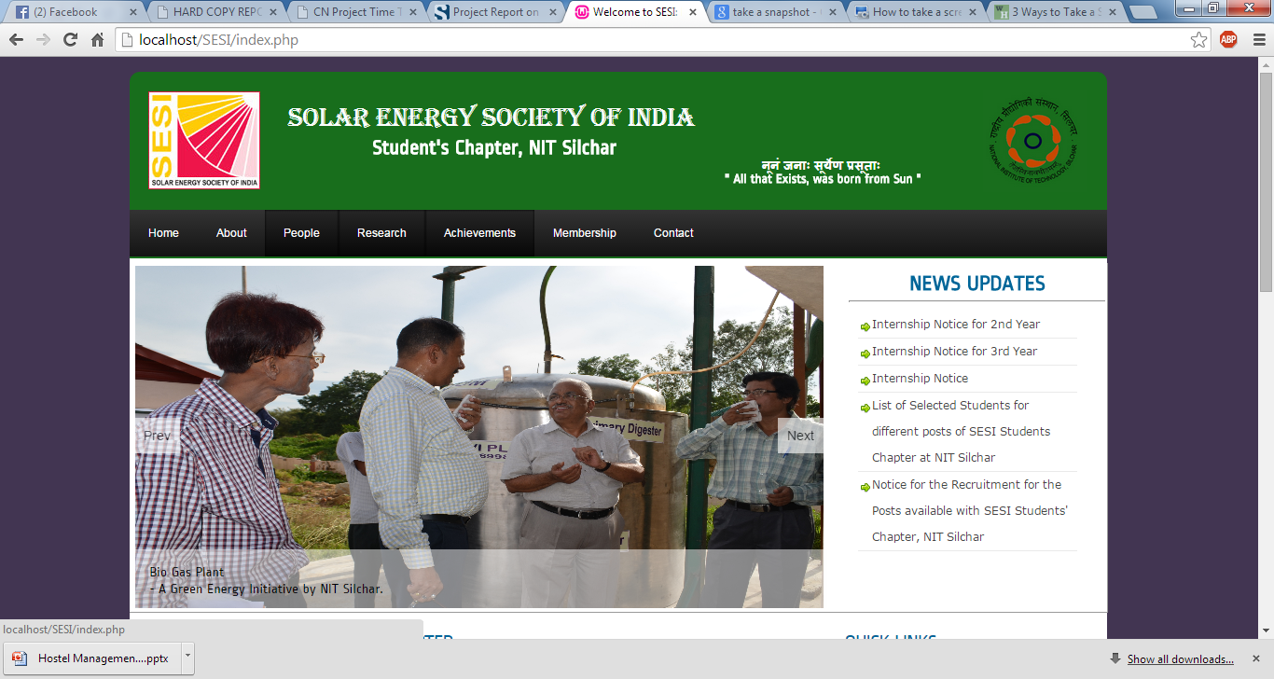

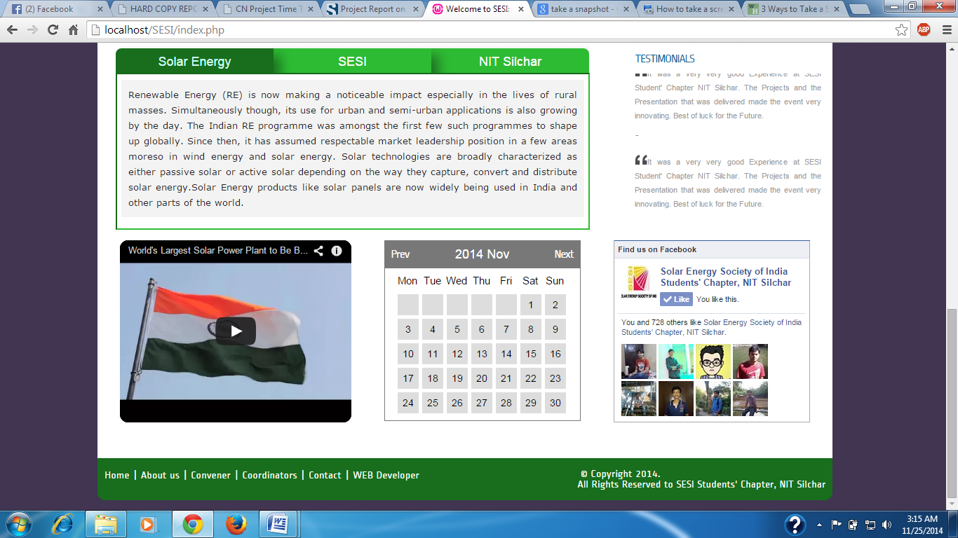

The Home page allows us to to view the various menus in the website like links to details of SESI chapter, People, Activities, Members, Awards, Contact Us etc.

It also has the short definitions about what the society does, about NIT Silchar and SESI in general.

**PHP Code for the Calendar:**

<?php

class Calendar {

/**

* Constructor

*/

public function __construct(){

$this->naviHref = htmlentities($_SERVER['PHP_SELF']);

}

/********************* PROPERTY ********************/

private $dayLabels = array("Mon","Tue","Wed","Thu","Fri","Sat","Sun");

private $currentYear=0;

private $currentMonth=0;

private $currentDay=0;

private $currentDate=null;

private $daysInMonth=0;

private $naviHref= null;

/********************* PUBLIC **********************/

/**

* print out the calendar

*/

public function show() {

$year = null;

$month = null;

if(null==$year&&isset($_GET['year']))

$year = $_GET['year'];

}else if(null==$year){

$year = date("Y",time());

}

if(null==$month&&isset($_GET['month'])){

$month = $_GET['month'];

}else if(null==$month){

$month = date("m",time());

}

$this->currentYear=$year;

$this->currentMonth=$month;

$this->daysInMonth=$this->_daysInMonth($month,$year);

$content='<div id="calendar">'.

'<div class="box">'.

$this->_createNavi().

'</div>'.

'<div class="box-content">'.

'<ul class="label">'.$this->_createLabels().'</ul>';

$content.='<div class="clear"></div>';

$content.='<ul class="dates">';

$weeksInMonth = $this->_weeksInMonth($month,$year);

// Create weeks in a month

for( $i=0; $i<$weeksInMonth; $i++ ){

//Create days in a week

for($j=1;$j<=7;$j++){

$content.=$this->_showDay($i*7+$j);

}

}

$content.='</ul>';

$content.='<div class="clear"></div>';

$content.='</div>';

$content.='</div>';

return $content;

}

/********************* PRIVATE **********************/

/**

* create the li element for ul

*/

private function _showDay($cellNumber){

if($this->currentDay==0){

$firstDayOfTheWeek = date('N',strtotime($this->currentYear.'-'.$this->currentMonth.'-01'));

if(intval($cellNumber) == intval($firstDayOfTheWeek)){

$this->currentDay=1;

}

}

if( ($this->currentDay!=0)&&($this->currentDay<=$this->daysInMonth) ){

$this->currentDate = date('Y-m-d',strtotime($this->currentYear.'-'.$this->currentMonth.'-'.($this->currentDay)));

$cellContent = $this->currentDay;

$this->currentDay++;

}else{

$this->currentDate =null;

$cellContent=null;

}

return '<li id="li-'.$this->currentDate.'" class="'.($cellNumber%7==1?' start ':($cellNumber%7==0?' end ':' ')).

($cellContent==null?'mask':'').'">'.$cellContent.'</li>';

}

/**

* create navigation

*/

private function _createNavi(){

$nextMonth = $this->currentMonth==12?1:intval($this->currentMonth)+1;

$nextYear = $this->currentMonth==12?intval($this->currentYear)+1:$this->currentYear;

$preMonth = $this->currentMonth==1?12:intval($this->currentMonth)-1;

$preYear = $this->currentMonth==1?intval($this->currentYear)-1:$this->currentYear;

return

'<div class="header">'.

'<a class="prev" href="'.$this->naviHref.'?month='.sprintf('%02d',$preMonth).'&year='.$preYear.'">Prev</a>'.

'<span class="title">'.date('Y M',strtotime($this->currentYear.'-'.$this->currentMonth.'-1')).'</span>'.

'<a class="next" href="'.$this->naviHref.'?month='.sprintf("%02d", $nextMonth).'&year='.$nextYear.'">Next</a>'.

'</div>';

}

/**

* create calendar week labels

*/

private function _createLabels(){

$content='';

foreach($this->dayLabels as $index=>$label){

$content.='<li class="'.($label==6?'end title':'start title').' title">'.$label.'</li>';

}

return $content;

}

/**

* calculate number of weeks in a particular month

*/

private function _weeksInMonth($month=null,$year=null){

if( null==($year) ) {

$year = date("Y",time());

}

if(null==($month)) {

$month = date("m",time());

}

// find number of days in this month

$daysInMonths = $this->_daysInMonth($month,$year);

$numOfweeks = ($daysInMonths%7==0?0:1) + intval($daysInMonths/7);

$monthEndingDay= date('N',strtotime($year.'-'.$month.'-'.$daysInMonths));

$monthStartDay = date('N',strtotime($year.'-'.$month.'-01'));

if($monthEndingDay<$monthStartDay){

$numOfweeks++;

}

return $numOfweeks;

}

/**

* calculate number of days in a particular month

*/

private function _daysInMonth($month=null,$year=null){

if(null==($year))

$year = date("Y",time());

if(null==($month))

$month = date("m",time());

return date('t',strtotime($year.'-'.$month.'-01'));

}

}

?>

**About Us:**

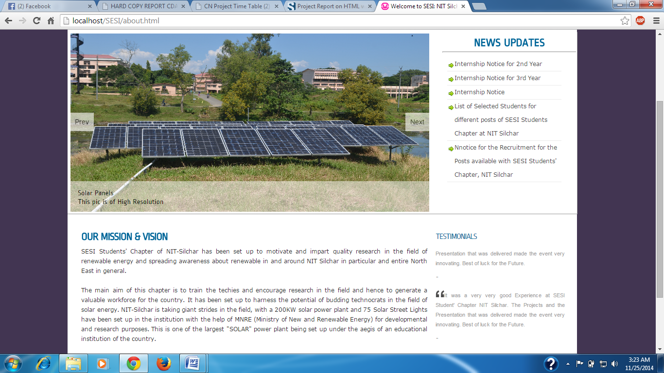

The About Us Page gives the definitions of the Mission and Aim of the SESI Students’ Chapter, NIT Silchar. It also describes the Society plans about the works to be carried out in the future**.**

**People:**

This is the Section where all the People active at present in the Society are listed. They include the Governing Council, Convener, Secretary of the Society, Treasurer, Coordinators, Alumunus and the members of the Society.

**Research:**

This is Section where all the Research activities in the society that are currently being carried out and also those that have been completed are being listed. Do have a look as it provides some very good projects that have also been patented**.**

**Achievements:**

This is Section where all the Achievements by the Society and its members be it anything from certificates to awards; all are listed here for the viewing of the users.

**Contact Us:**

This is section which contains the contact form that validates the data and sends it to the admin E-mail Id by using a PHP Script. Through it the user can ask any querry that comes in his mind, SESI will respond to it.

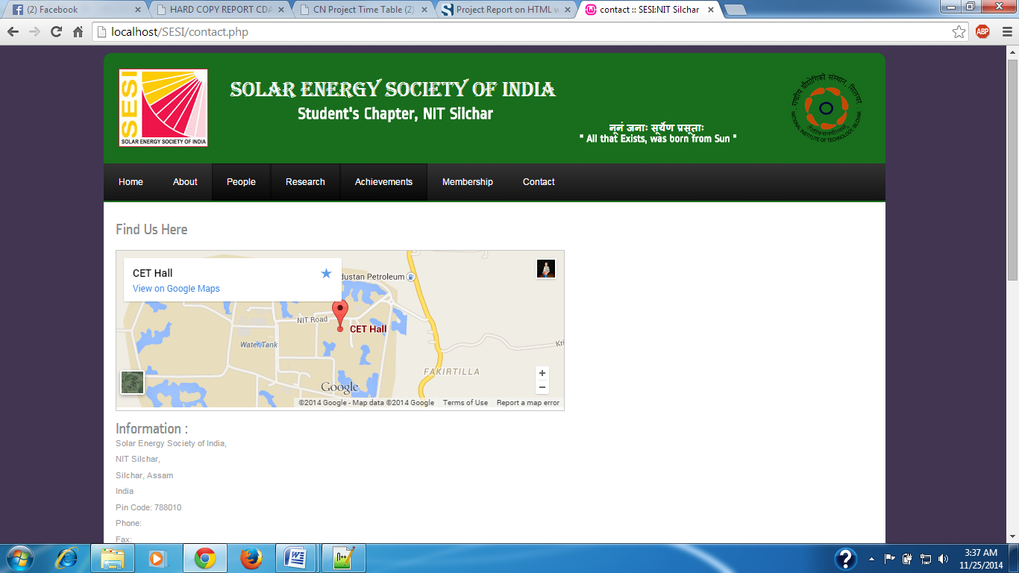

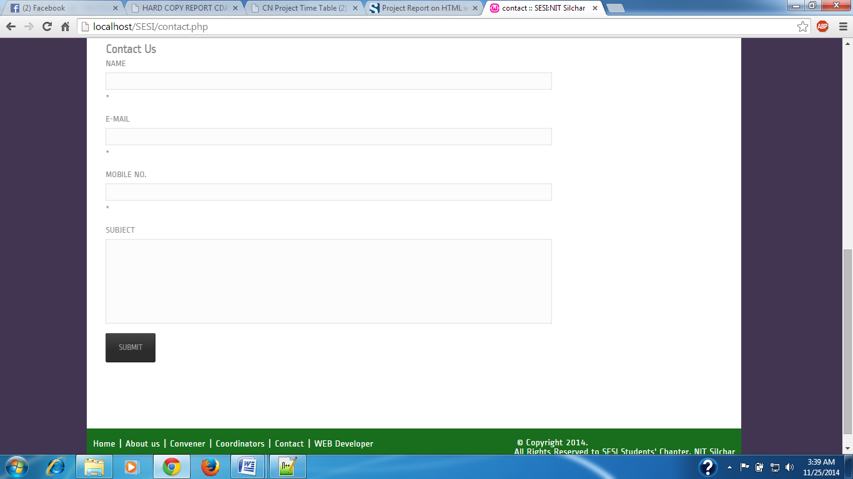

**CONCLUSION**

To conclude the description about the project : The project, developed using html, css, Javascript, Jquerry & PHP is based on the requirement specification of the user and the analysis of the existing system, with flexibility for future enhancement.

The expanded functionality of today’s website requires an appropriate approach towards web development.This Website ha been designed for people who want to manage various activi-ties in the Society. For the past few years the activities in the society is increasing rapidly.

Thereby the number of members and coordinatos are also increasing for keeping up the pace of activities going on in the college This particular project deals with the problems on managing the contents of the society and avoids the problems which occur when carried manually.

Identification of the drawbacks of the existing system leads to the designing of computerized system that will be compatible to the existing system with the system which is more user friendly and more GUI oriented.